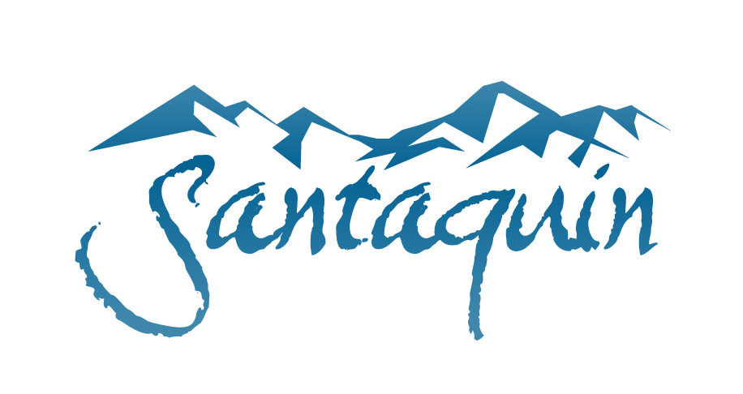
NOTICE OF PUBLIC HEARING (LBA)
FY 2024-2025 BUDGET AND TRANSFERS

Notice is given that the Santaquin City Local Building Authority will hold a Public Hearing on May 22nd, 2024, at approximately 7:00 PM at Santaquin City Hall, 110 S. Center St. Santaquin, UT 84655.
The public is invited to participate in person or view electronically through the following website address: https://www.youtube.com/channel/UCTzZT_yW2H2Hd-58M2_ddSw
The purpose of the Public Hearings numbered below is to receive public input for the consideration of the LBA:
- Local Building Authority: FY 2024-2025 Budget and transfers therein.
The documents associated with these hearings will be available for inspection on the city website homepage at www.santaquin.org, no later than May 17, 2024.

Certificate of Posting
The undersigned duly appointed City Recorder for the municipality of Santaquin City hereby certifies that a copy of the foregoing notice may be found at www.santaquin.org, in three physical locations (Santaquin City Public Safety Building, Zions Bank, Santaquin Post Office), and on the State of Utah’s Public Notice Website, https://www.utah.gov/pmn/index.html. A copy of the notice may also be requested by calling (801)754-1904.

Dated this 14th day of May, 2024.
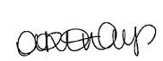
By:
Amalie R. Ottley, City Recorder

